How to Encrypt a File in Office 2013

If you have a document that contains sensitive personal information – never send it in an email without first encrypting the file. When you send the encrypted file, always send the password in a separate email.

Warning – once encrypted, data can probably never be recovered without the password. It may be years before the file is needed, and if the password is forgotten, the file is worthless. Don't rely on your memory. In addition, if something were to happen to you, consider if others in your department would need access to the data. Make sure that passwords are stored some place safe before encrypting important information and make sure the passwords (or the location of the passwords) are made available to the appropriate personnel.

After you have created a file in Word, Excel or PowerPoint, you can encrypt the file.

- Click on the File the top left corner of the window.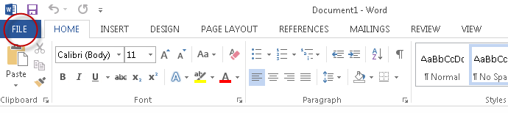

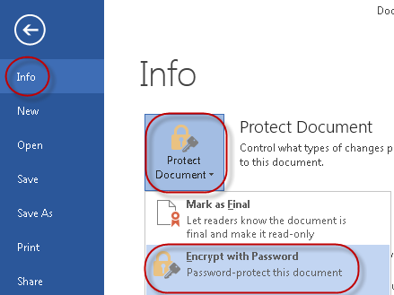
- Select Info.

- Choose Protect Document

- Then select Encrypt with Password.

- Enter a strong password and click OK

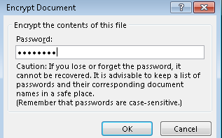

- Retype the same password when you are prompted to do so.

When someone tries to open the document, they will be prompted for the password.

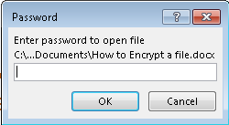

To delete the password:

- Repeat the above steps.

- When you click “Encrypt with a Password,”delete the password and click save.

